**AWS Assignment-04**

**Console**

1. Create Launch Template on Console:  
   - Navigate to the EC2 dashboard on the AWS Management Console.  
   - Create a launch template named "WebServerTemplate."  
   - Specify configurations such as instance type, key pair, and any additional settings.

2. Launch Instance Using Launch Template:  
   - Use the launch template "WebServerTemplate" to launch an EC2 instance.  
   - Verify the successful launch of the instance.

3. Modify Launch Template:  
   - Modify the launch template to change the instance type or any other parameter.  
   - Use the modified template to launch another instance.

4. Documentation:  
   - Provide a step-by-step guide with screenshots for creating, launching, and modifying instances using the launch template.  
   - Include outputs or confirmation messages from the console.

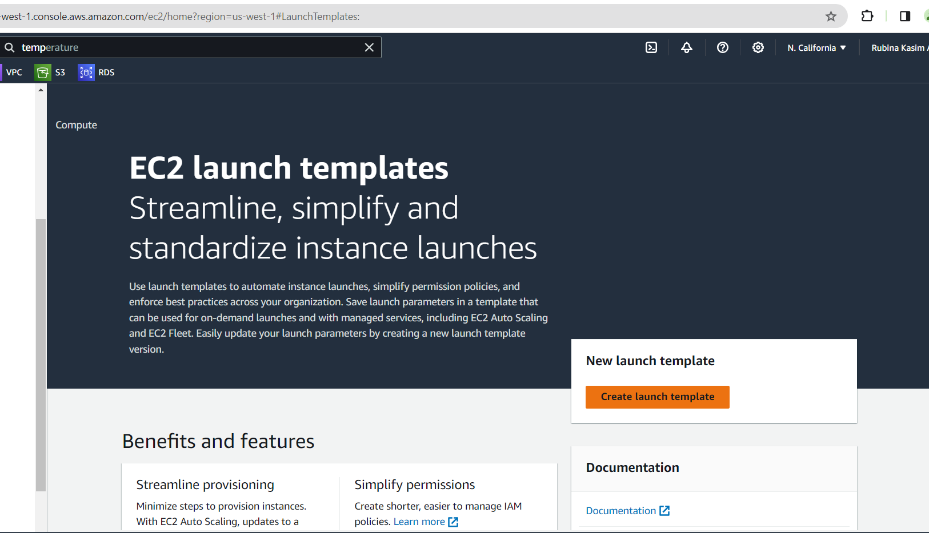

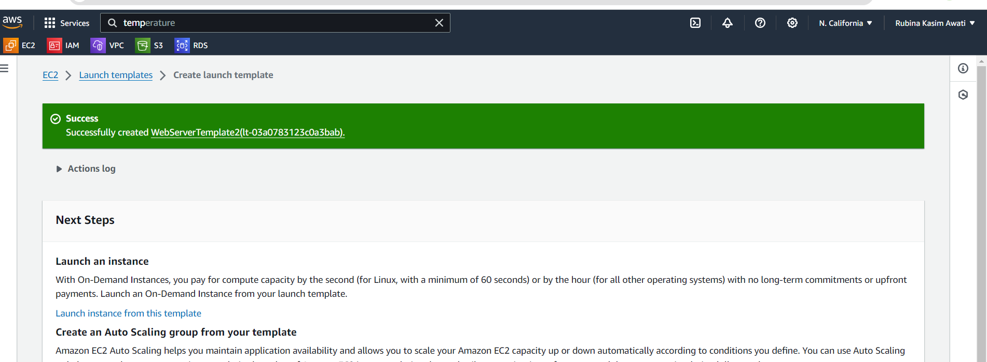

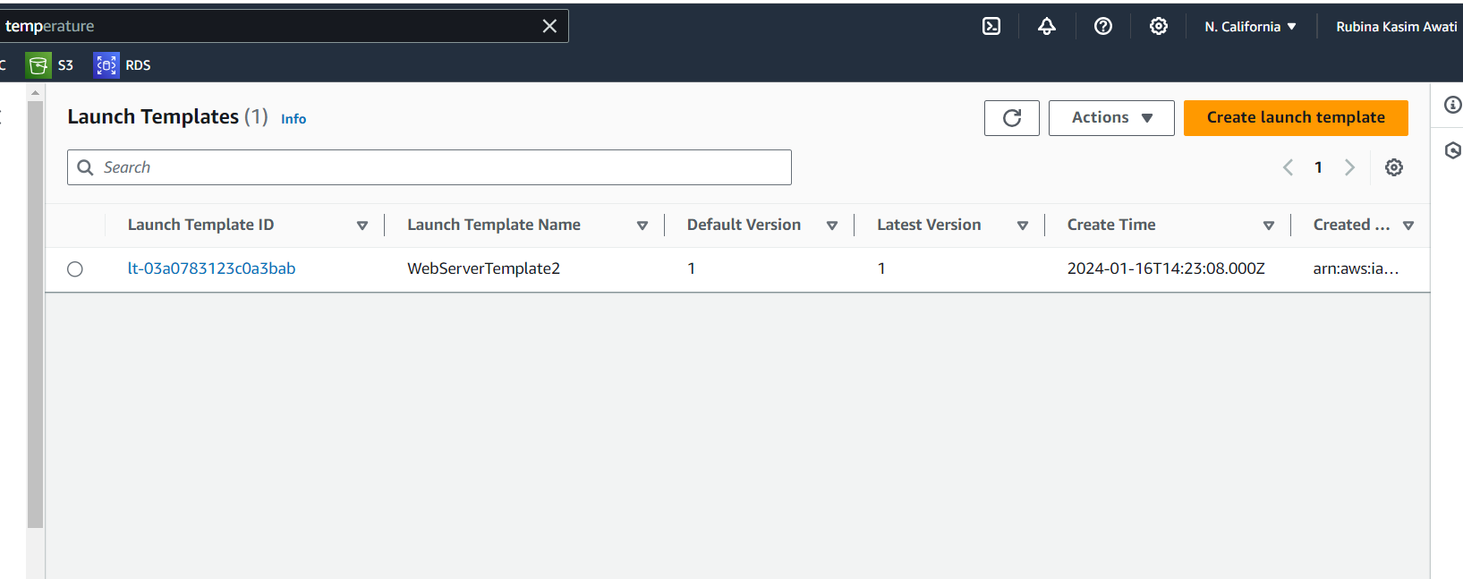

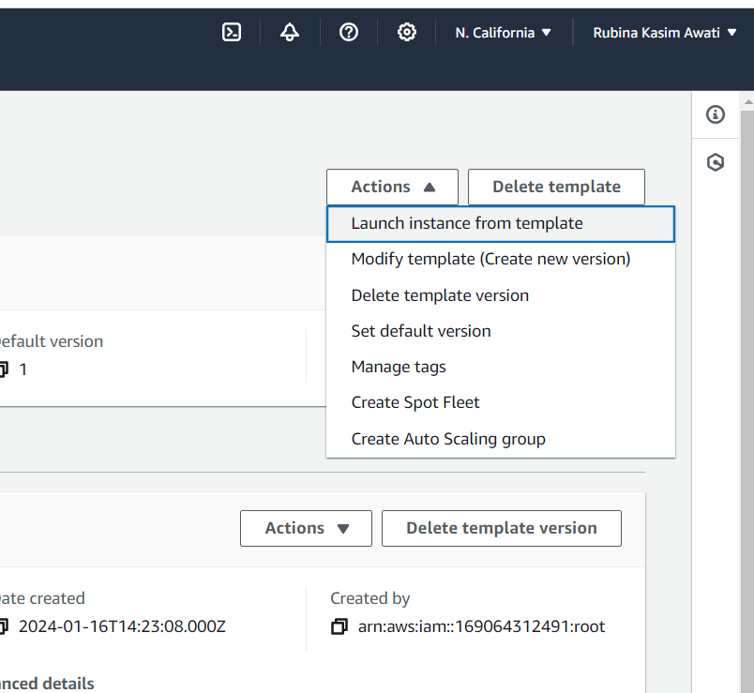

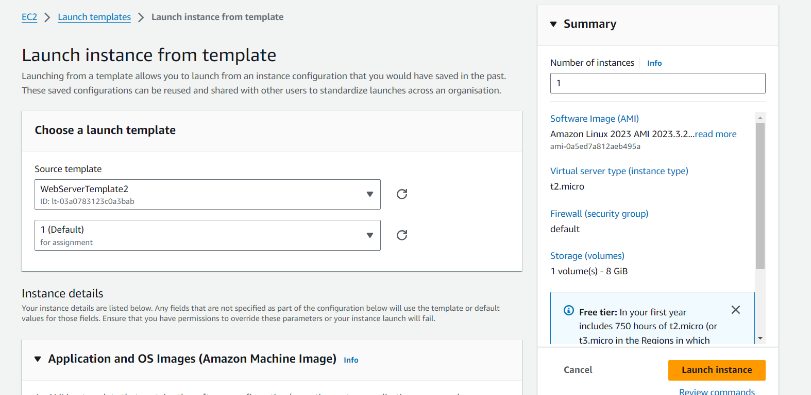

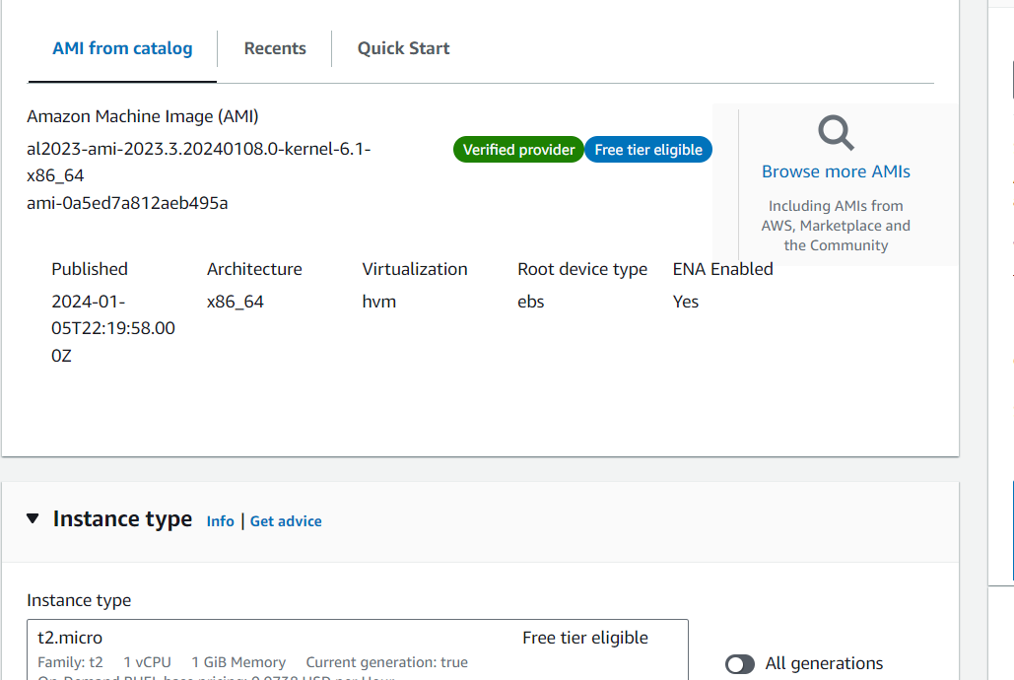

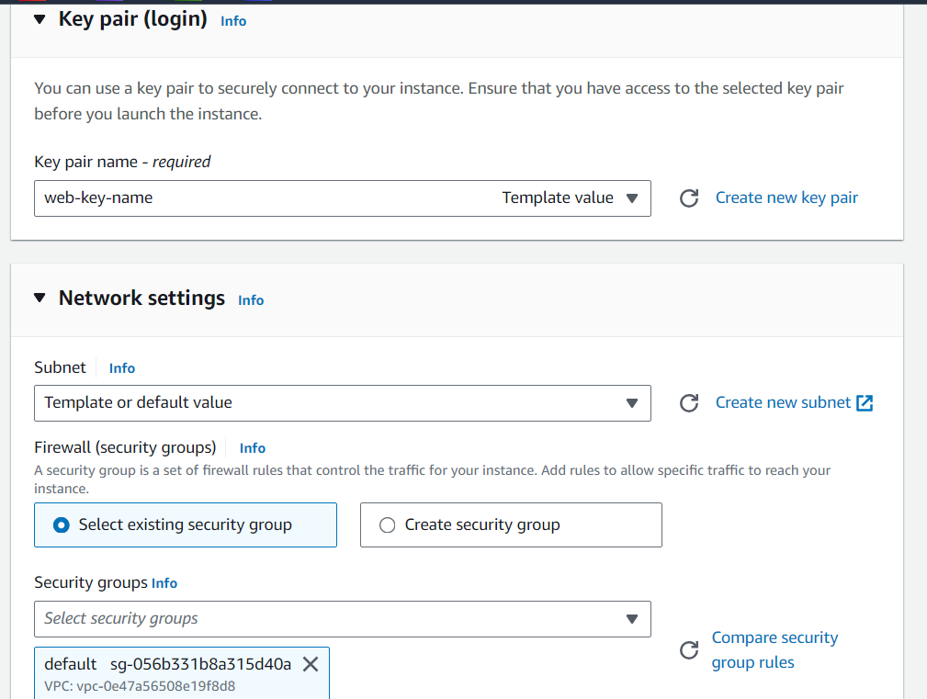

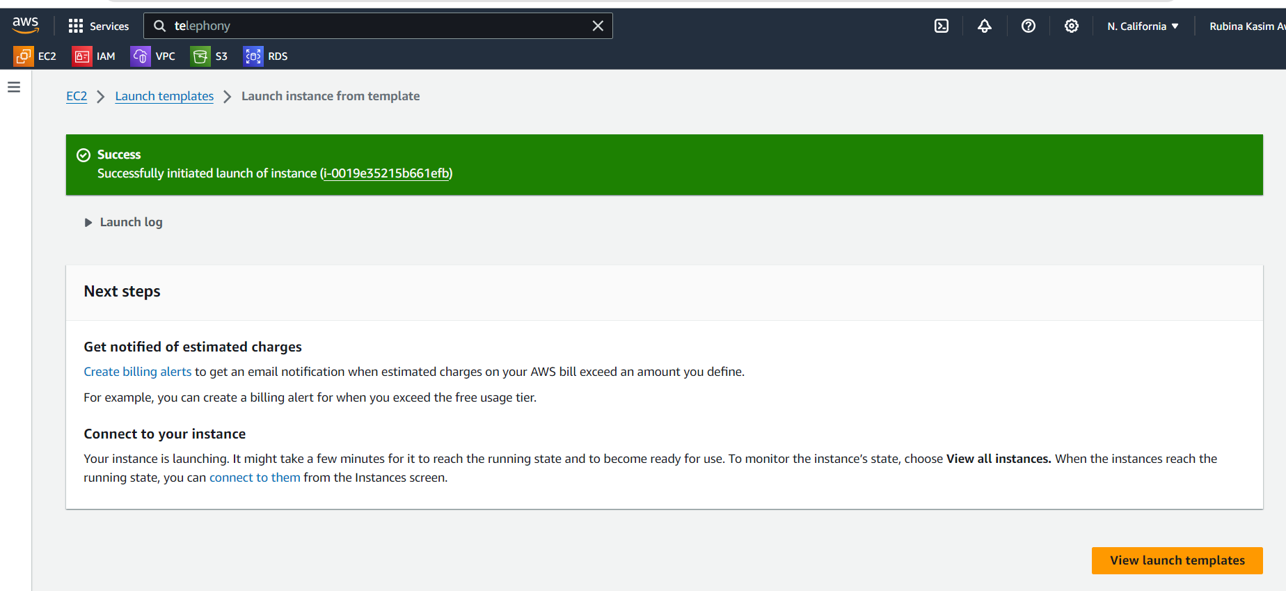

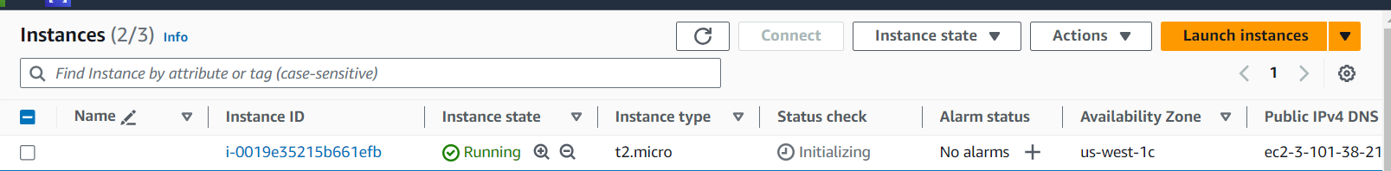

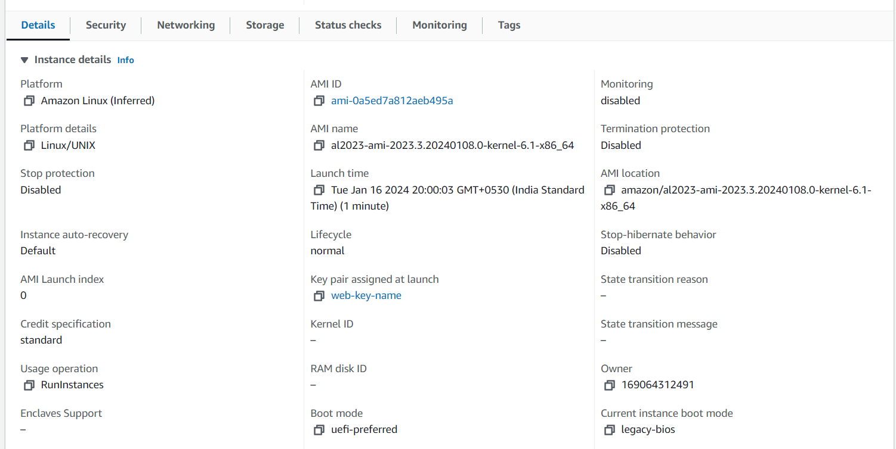

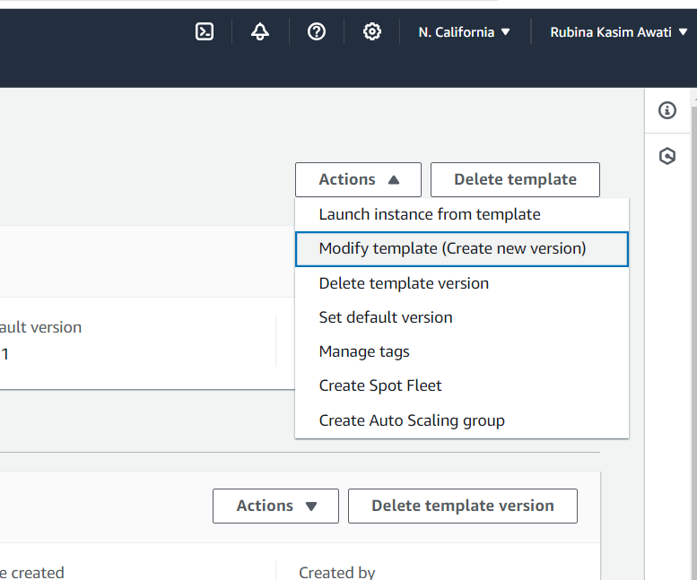

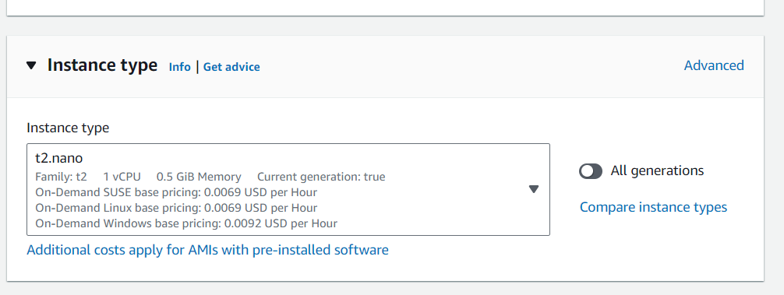

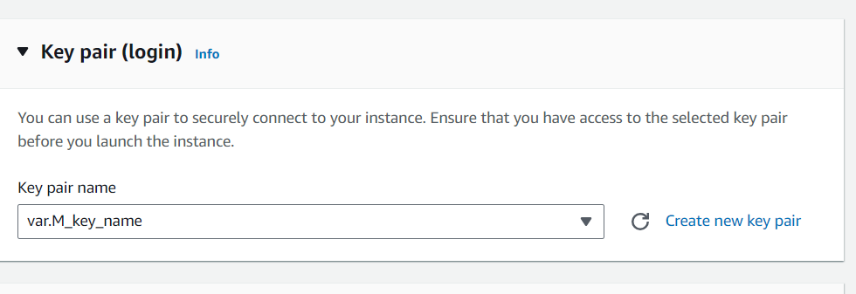

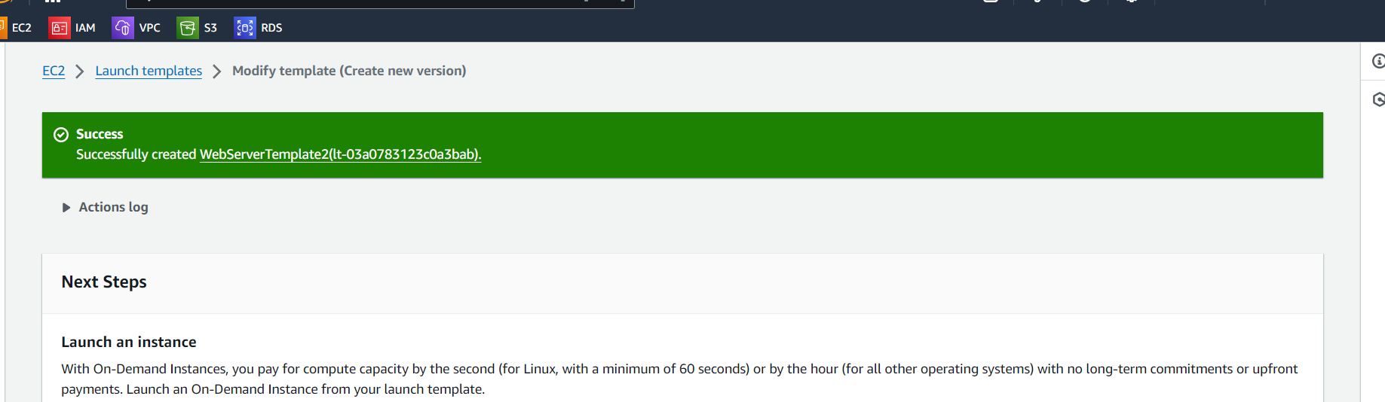

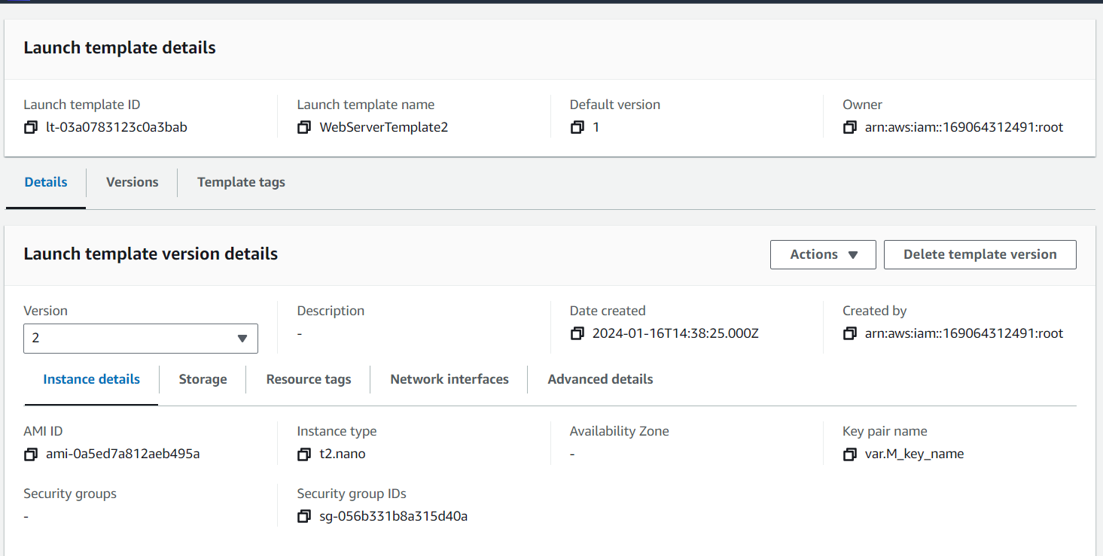

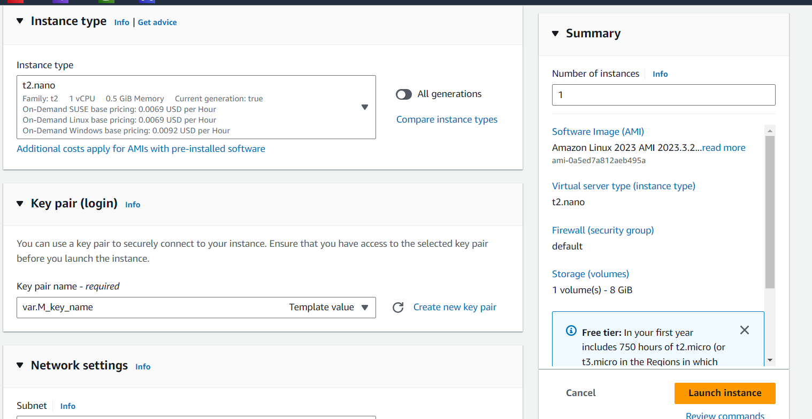 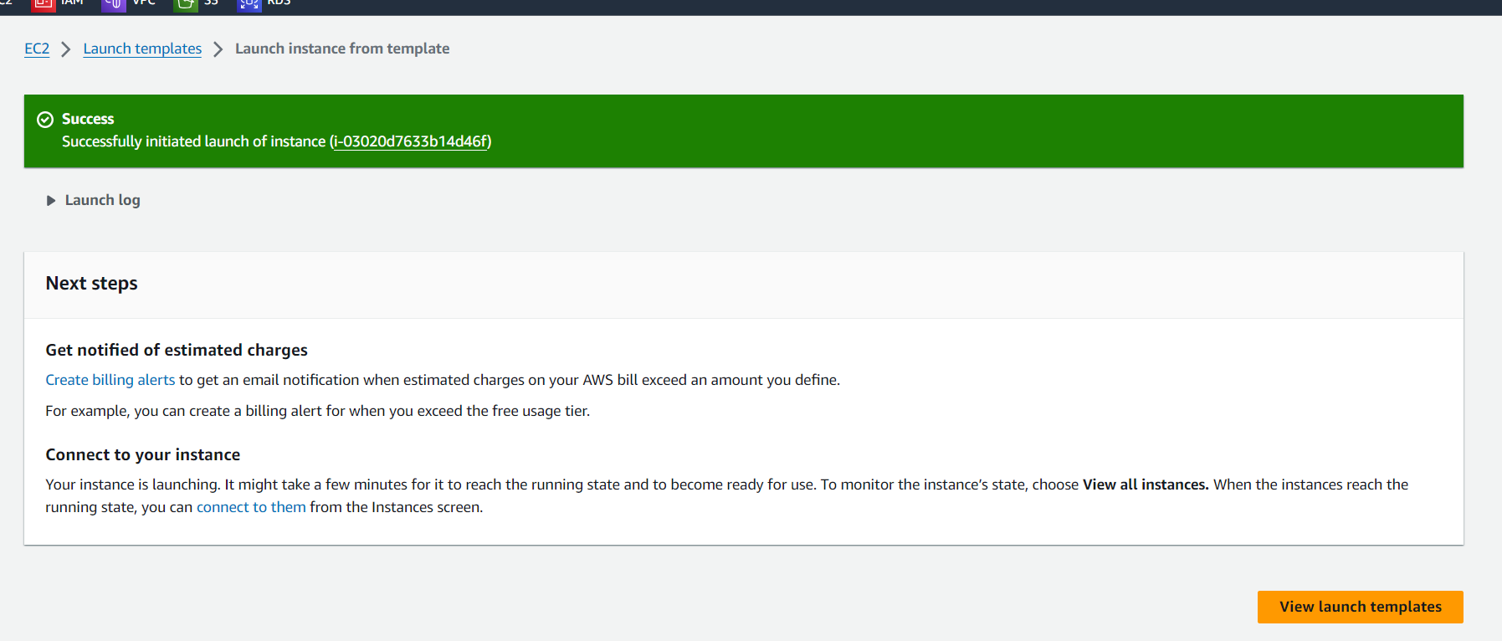

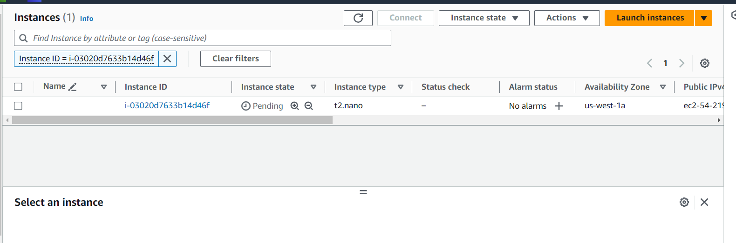

**CLI**

1. Create Launch Template using AWS CLI:  
   - Use the AWS CLI to create a launch template named "WebServerTemplate" with specified configurations.  
   - Confirm the creation of the launch template.

2. Launch Instance Using Launch Template:  
   - Use the AWS CLI to launch an EC2 instance using the "WebServerTemplate."  
   - Confirm the successful launch of the instance.

3. Modify Launch Template using AWS CLI:  
   - Use the AWS CLI to modify the launch template, e.g., change the instance type.  
   - Use the modified template to launch another instance.

4. Documentation:  
   - Provide a document with AWS CLI commands for creating, launching, and modifying instances using the launch template.  
   - Include any relevant outputs or confirmation messages.

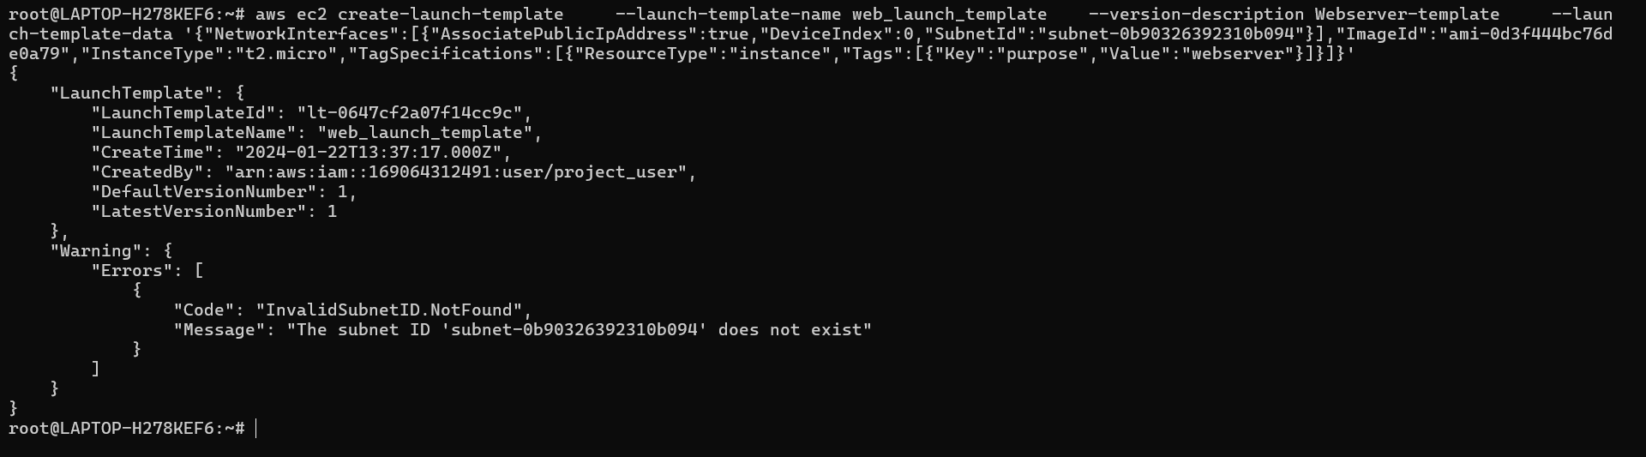

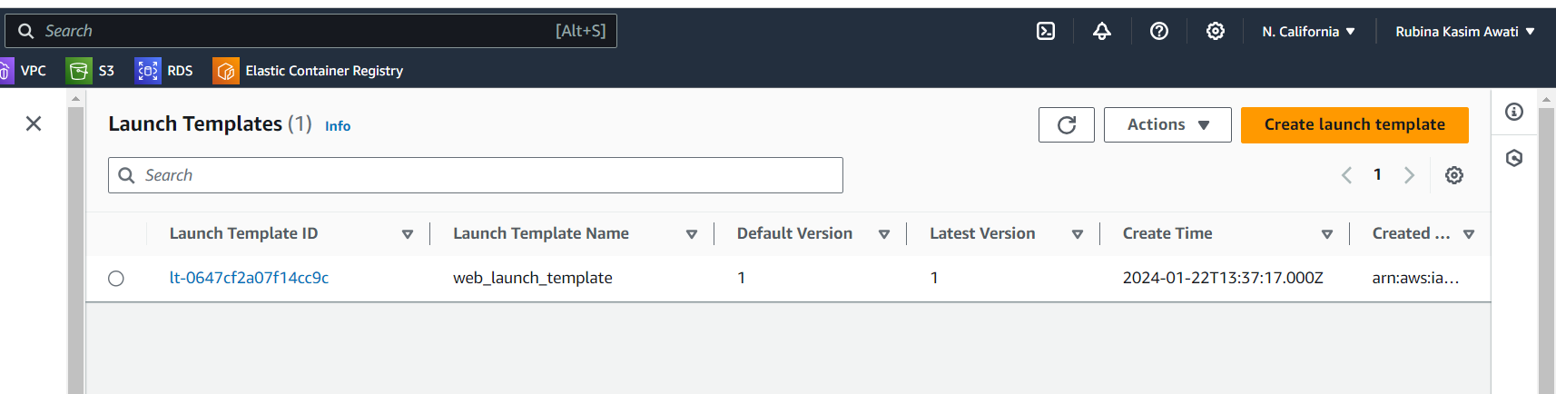

1.2.

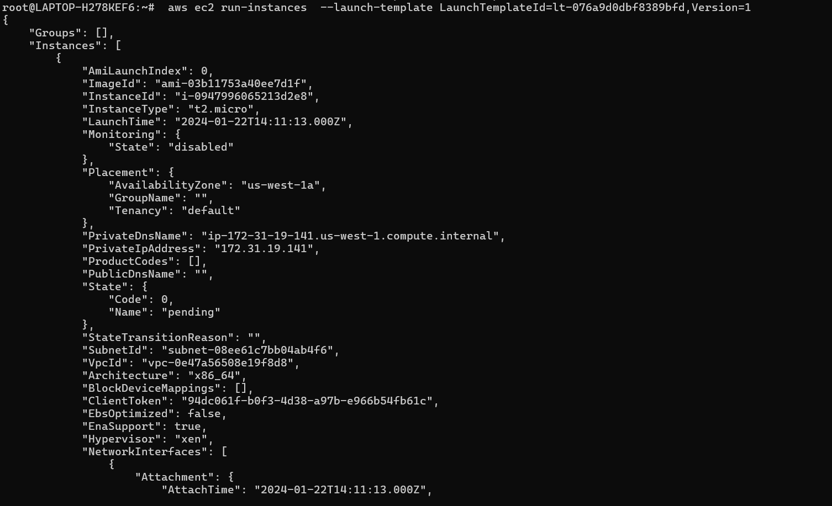

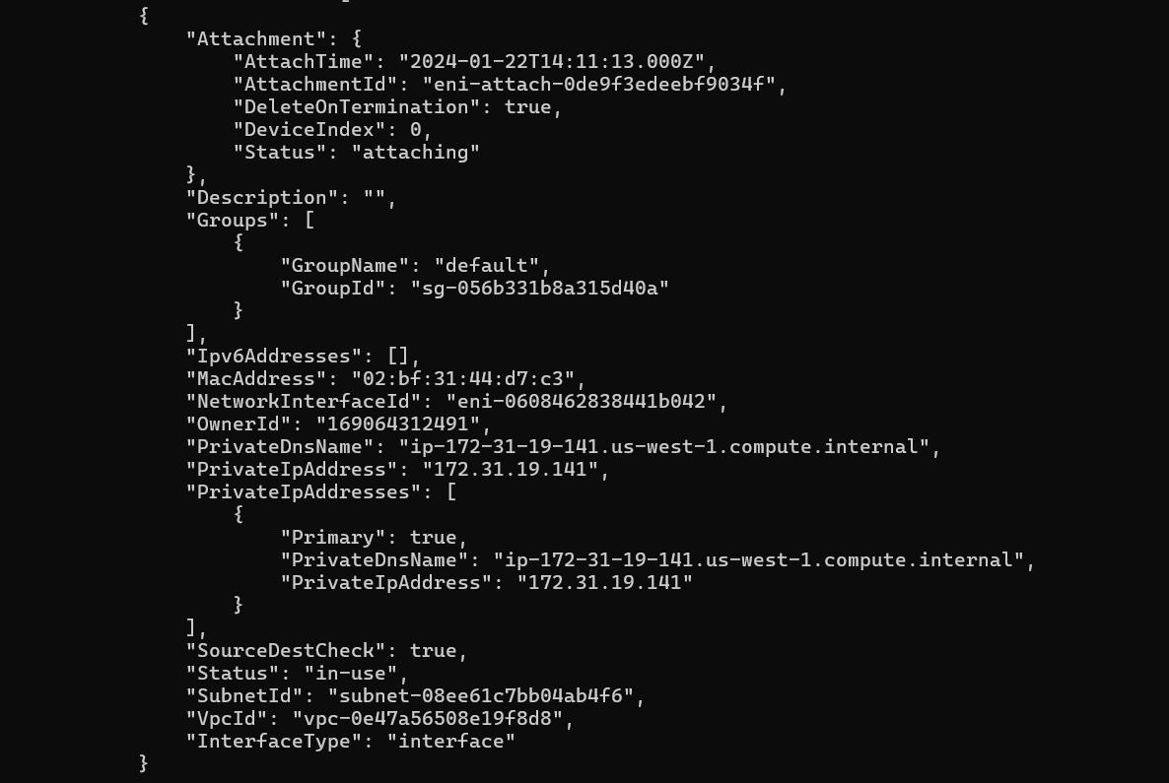

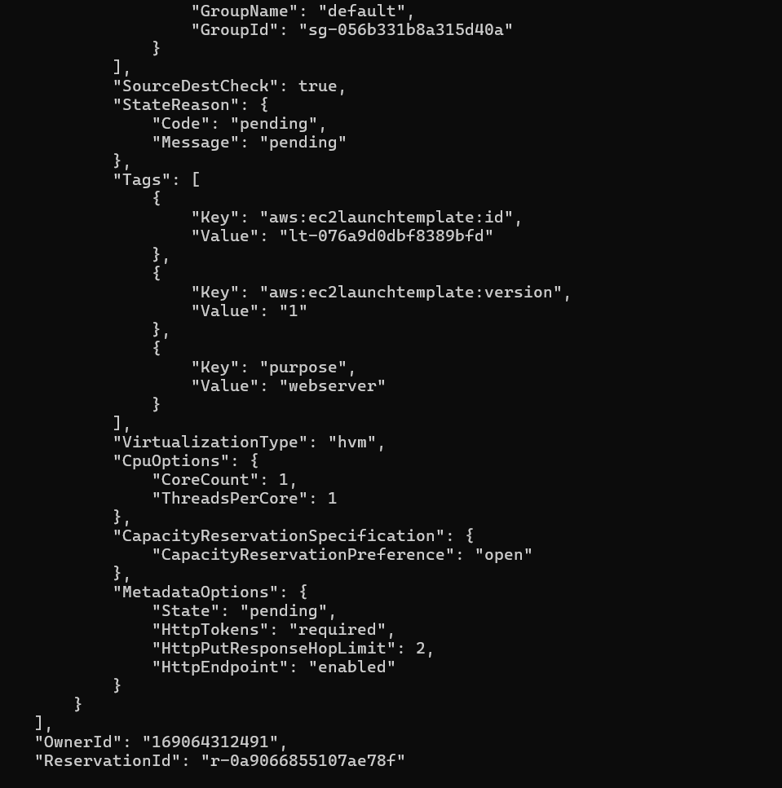

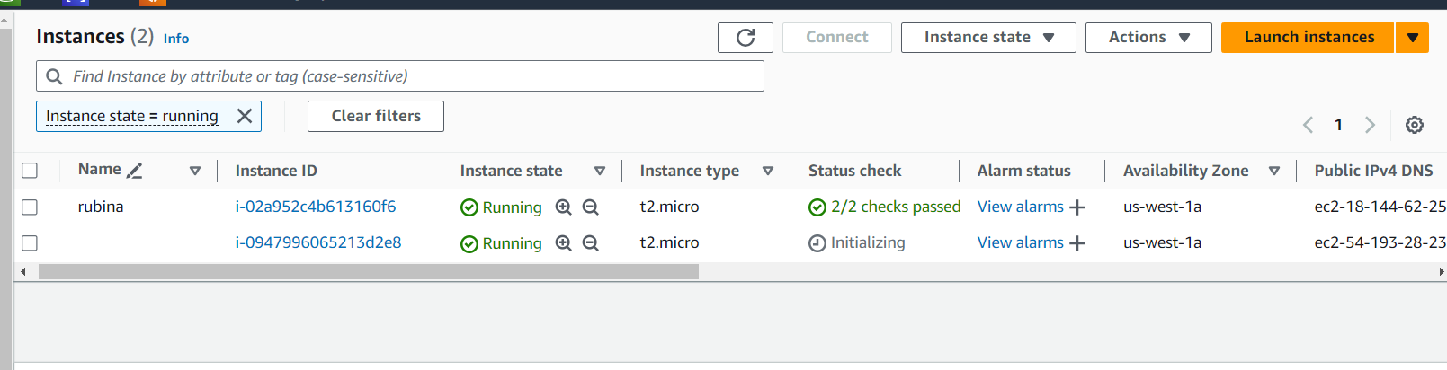

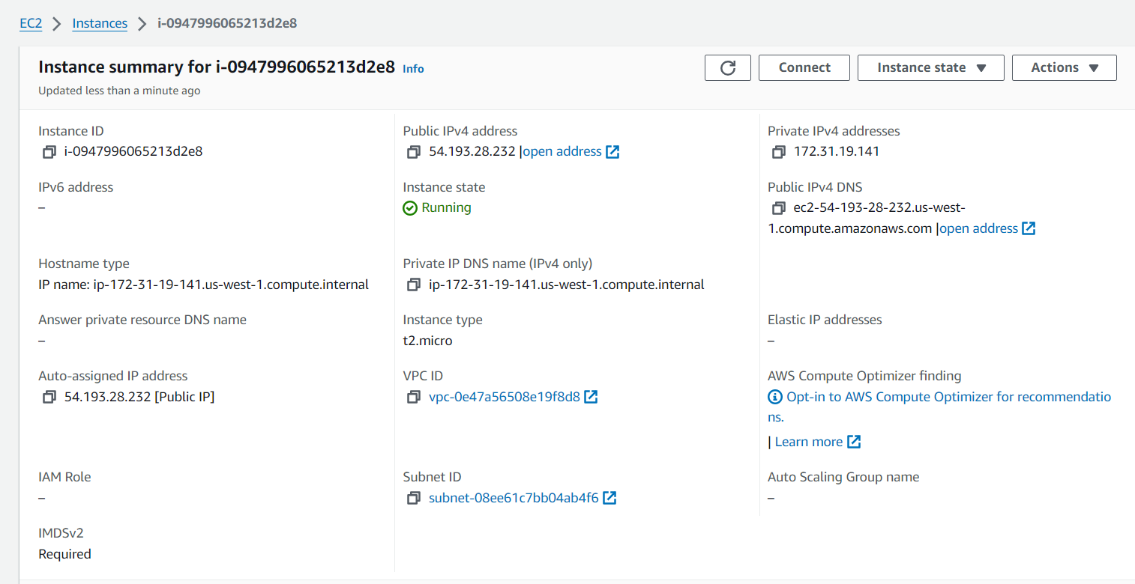

1.3

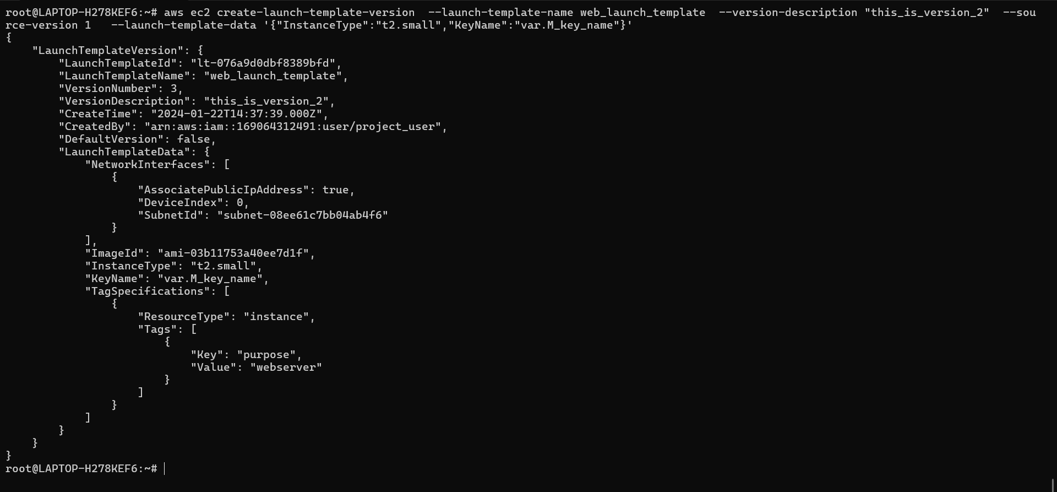

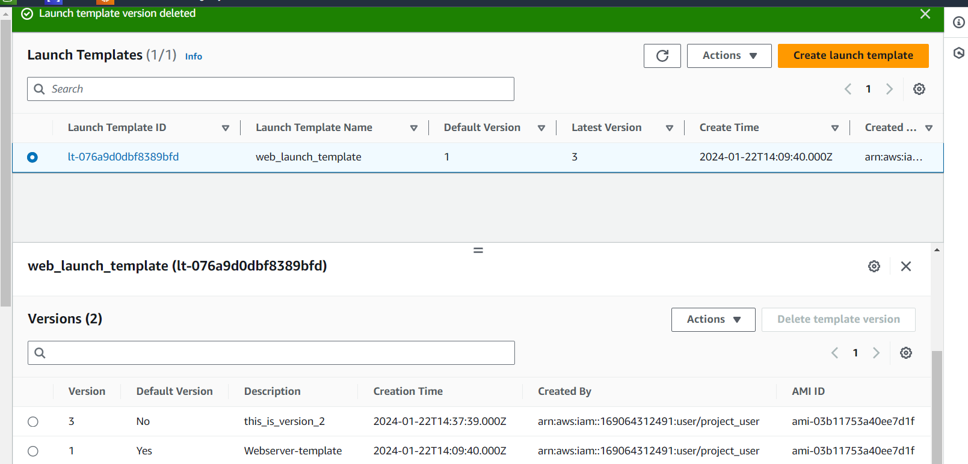

Que-2

1. Allocate Elastic IP and Associate:  
   - Using the AWS Management Console, allocate an Elastic IP address.  
   - Associate the Elastic IP with an existing running EC2 instance.

2. Verify Elastic IP Functionality:  
   - Confirm the functionality of the Elastic IP by accessing the associated EC2 instance.  
   - Document any observations or considerations related to Elastic IP usage.

3. Swap Elastic IPs:  
   - Allocate another Elastic IP and swap it with the original Elastic IP.  
   - Document the steps taken and verify the new Elastic IP functionality.

4. Documentation:  
   - Provide a step-by-step guide, including screenshots, for allocating, associating, and swapping Elastic IPs.  
   - Include evidence of the successful verification of Elastic IP functionality.

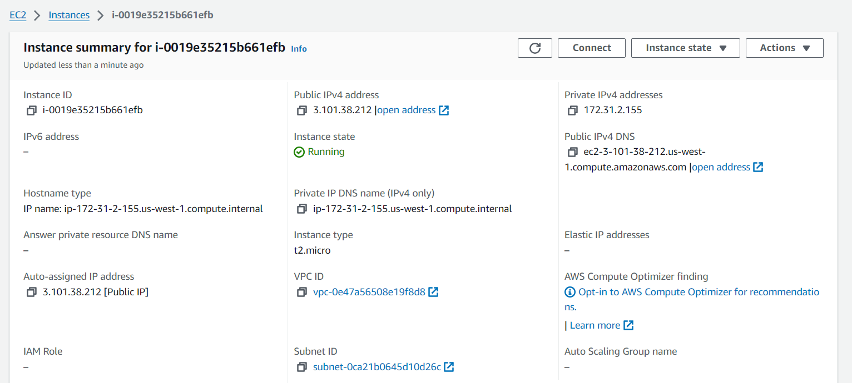

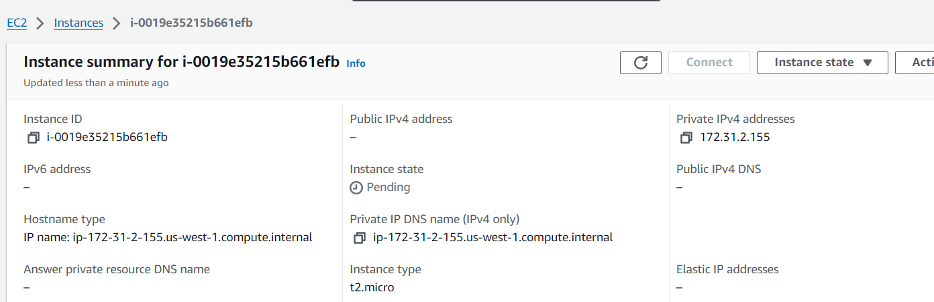

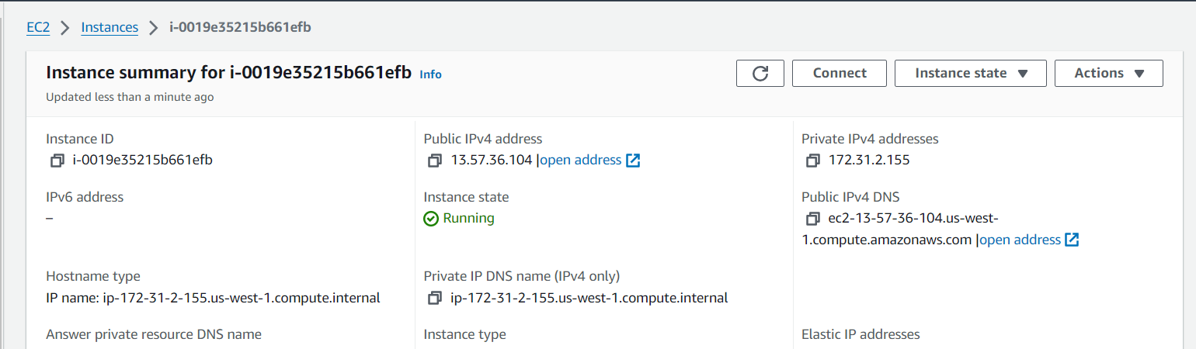

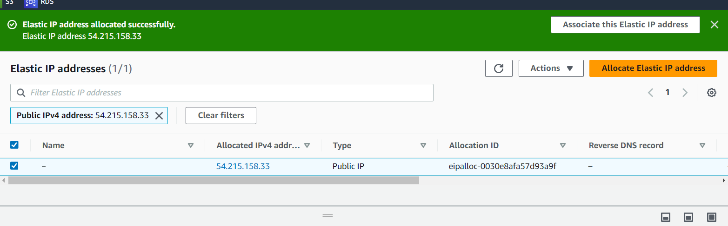

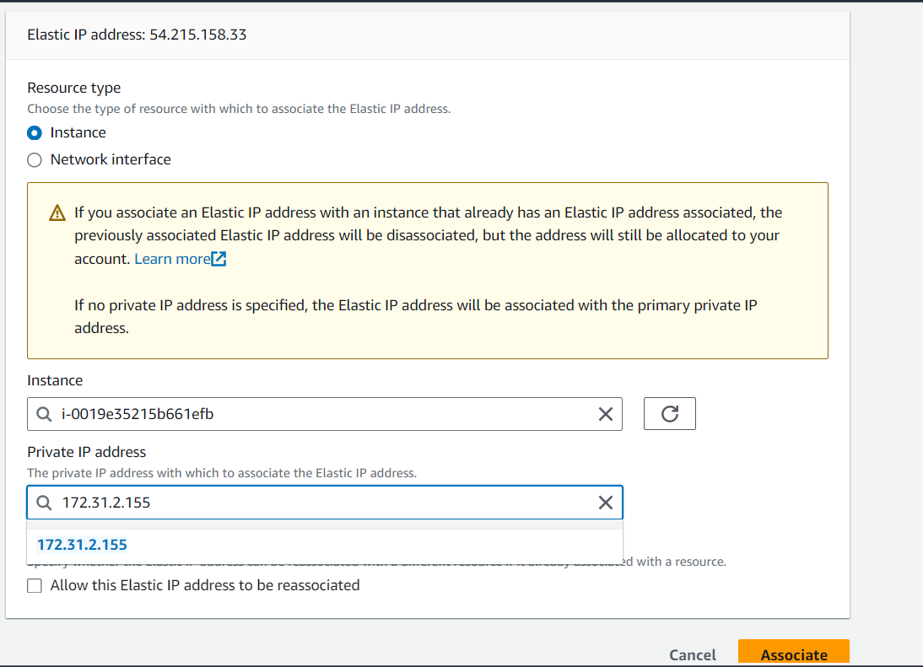

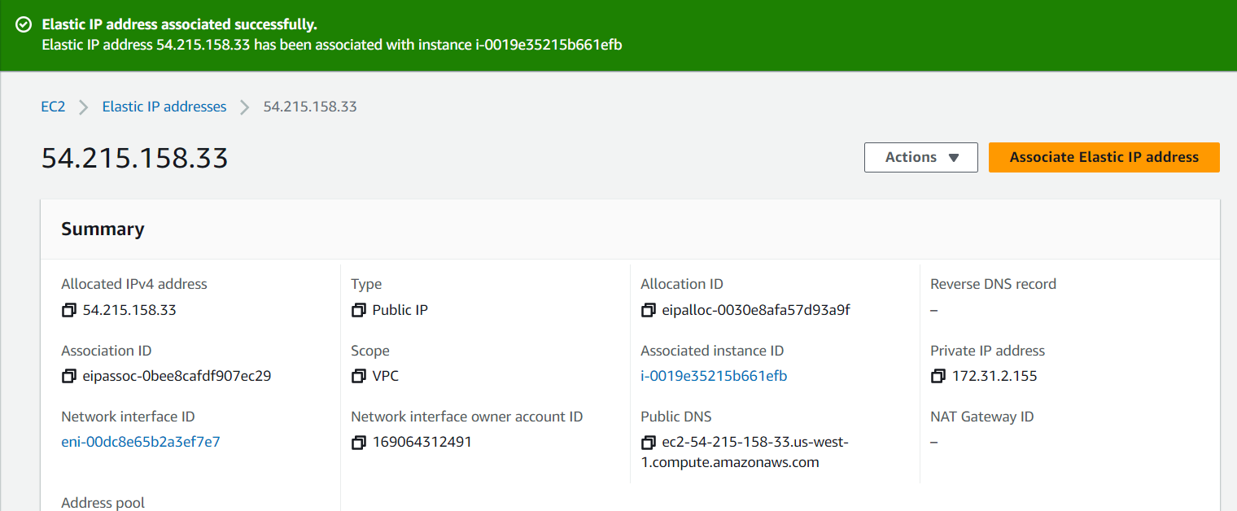

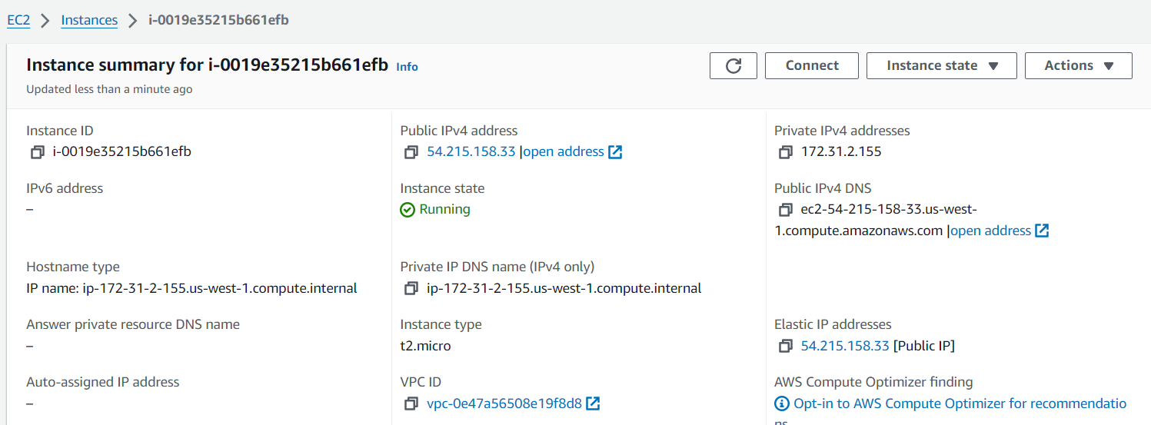

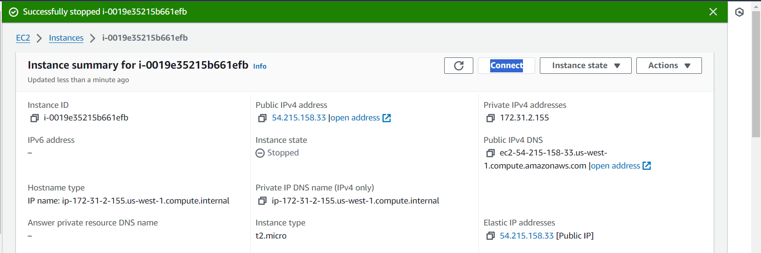

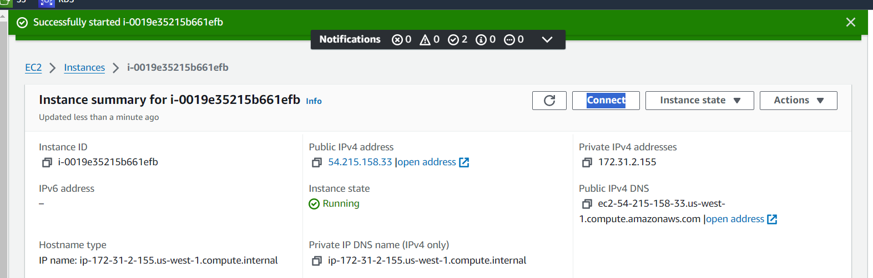

CLI

1. Allocate Elastic IP and Associate using AWS CLI: - Use the AWS CLI to allocate an Elastic IP address. - Associate the Elastic IP with an existing running EC2 instance.

2. Verify Elastic IP Functionality using AWS CLI: - Use the AWS CLI to confirm the functionality of the Elastic IP by accessing the associated EC2 instance. - Document any observations or considerations related to Elastic IP usage.

3. Swap Elastic IPs using AWS CLI: - Use the AWS CLI to allocate another Elastic IP. - Swap the newly allocated Elastic IP with the original one. - Document the steps taken and verify the new Elastic IP functionality.

4. Documentation: - Provide a detailed document with AWS CLI commands for allocating, associating, and swapping Elastic IPs. - Include evidence of the successful verification of Elastic IP functionality.

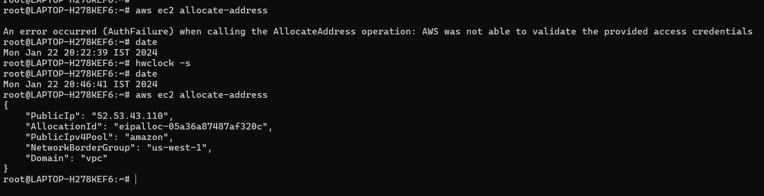

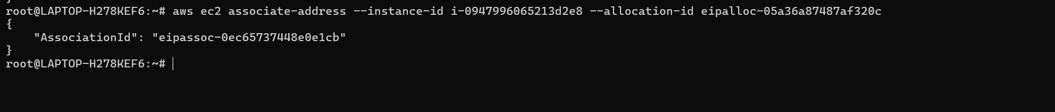

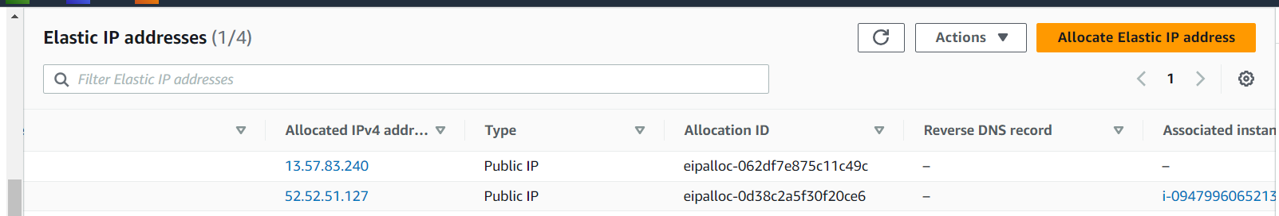

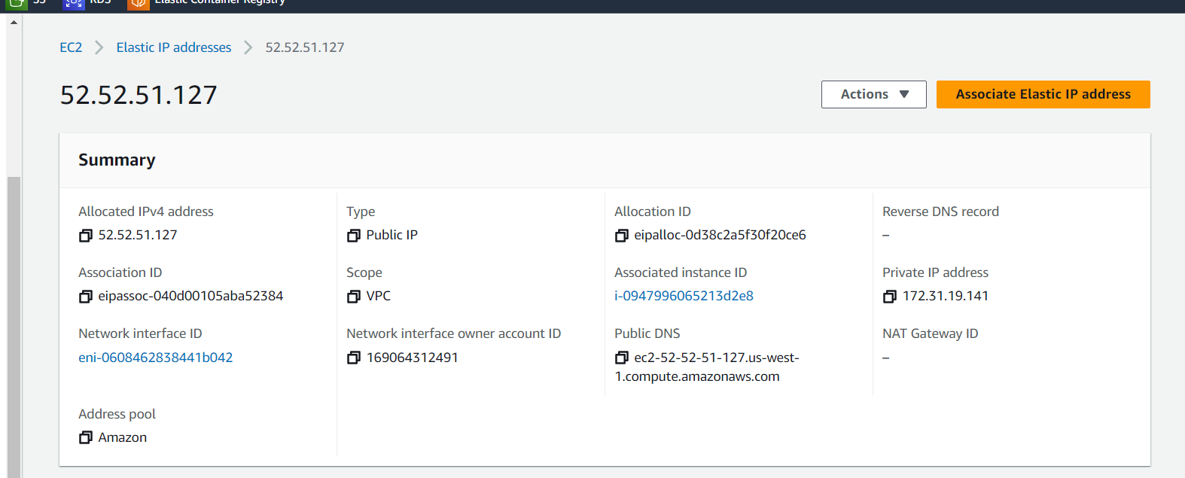

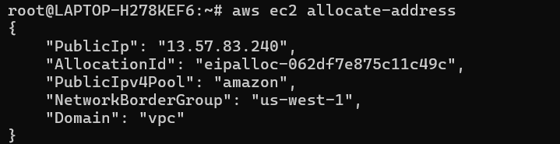

Que-3

**Console**

1. Create Partition Placement Group:  
   - Using the AWS Management Console, create a "Partition" placement group.  
   - Ensure it is associated with a specific region.

2. Launch Instances into Partition Placement Group:  
   - Launch multiple EC2 instances into the created "Partition" placement group with distinct partition numbers.  
   - Confirm that instances are distributed across partitions.

3. Test Isolation:  
   - Use the console to observe the network and resource isolation between instances in different partitions.  
   - Verify that instances in one partition do not share the underlying hardware with instances in other partitions.

4. Documentation:  
   - Provide a step-by-step guide + screenshots, for creating a "Partition" placement group and launching instances into it.  
   - Include observations related to network and resource isolation.

